## **Day 4 Coding Screenshots:**

Doctor Object oriented programming:

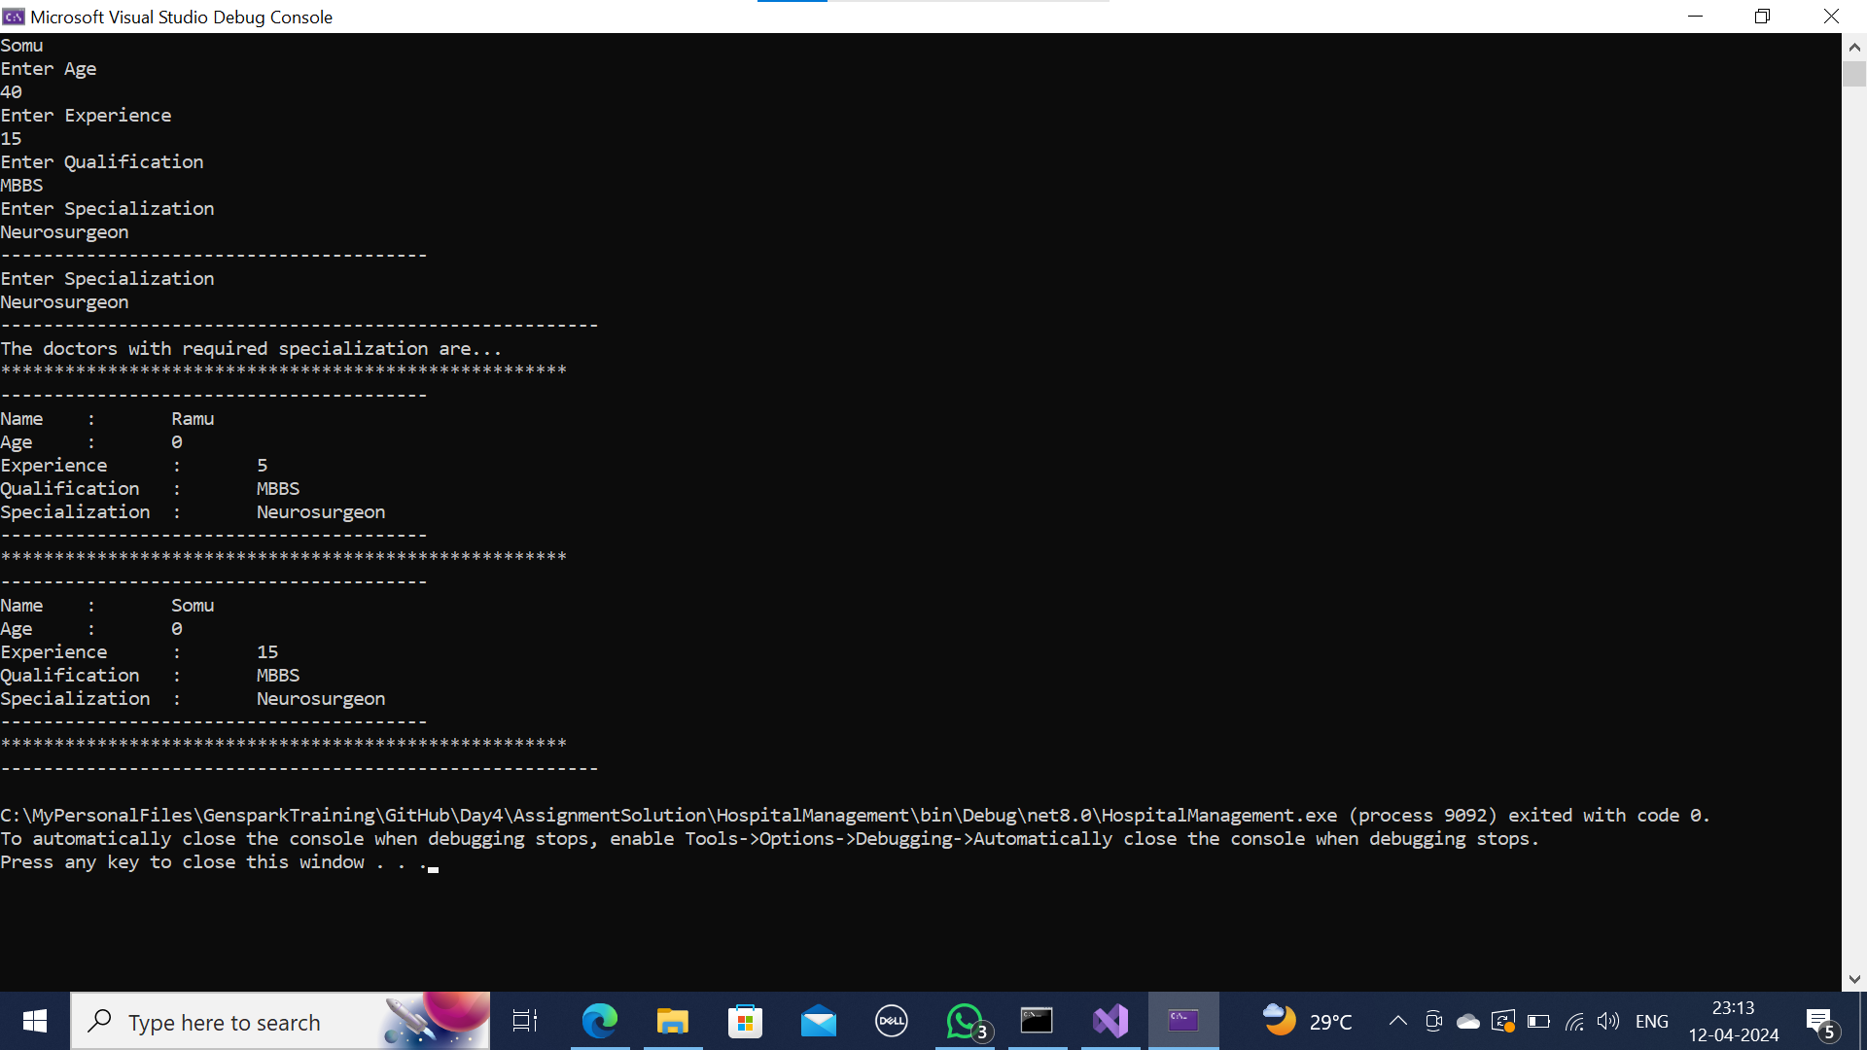

Card Number problem:

